Docker Desktop Installation for Windows

* Navigate to <https://docs.docker.com/desktop/install/windows-install/> and click on ‘Download Docker Desktop for Windows’
* 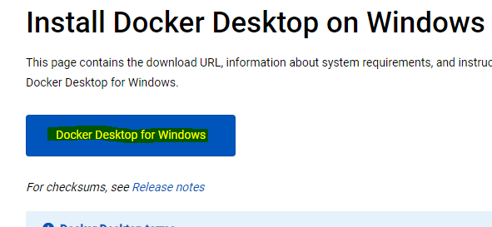
* Run the .exe file to install Docker
* Run ‘Docker Desktop’ from Windows Start Menu and minimize it
* Test installation: Open a new cmd terminal and run the command: **docker –help**

Minikube installation

* Navigate to <https://minikube.sigs.k8s.io/docs/start/> and click on ‘latest release’
* 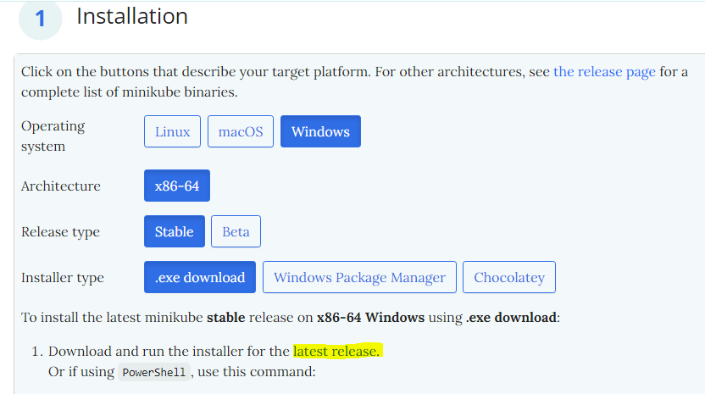
* Run the .exe file to install minikube
* Test installation: Open a new cmd terminal and run the command: **minikube –help**
* Note: Kubectl, cluster manager of Kubernetes also gets installed along with minikube
* To test it’s installation, run the command **kubectl –help**

Start Minikube:

* From a cmd terminal with Administrator permissions, run the command:
* **minikube start –driver=docker** to start minikube
* To check the status, use **minikube status**

**Get all nodes in the cluster:**

* Use the command: **kubectl get node**

**Demo Project:**

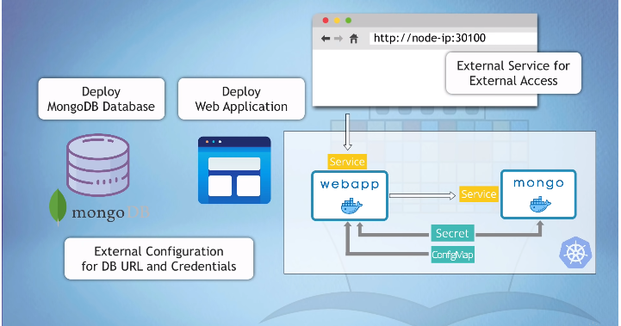

Configuration Files:

For config file reference and detailed info about any component visit: <https://kubernetes.io/docs/home/>

